The complements of Urdu postpositions are marked with a structural case. This case is realized on all elements inside the DP which have this case form available. Case concord is found in other languages such as German where accusative, genitive, and dative case will be realized on the determiner, adjective and noun inside a DP.

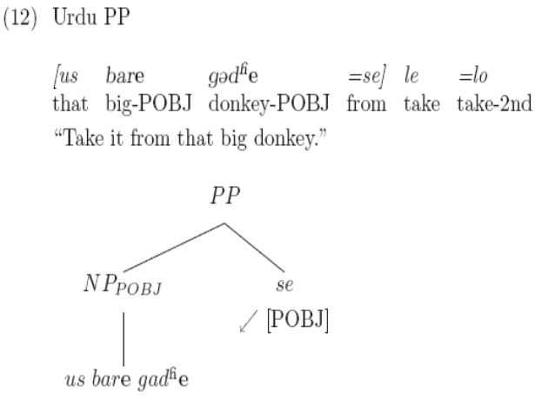

German example:

Elements which show this structural case
Nouns
Genitive posposition
Gerunds
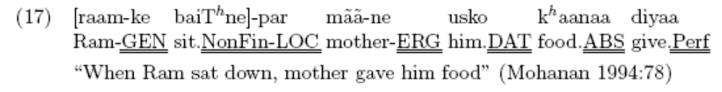
Pronouns? (vo,je vs us,is?)
Adjectives

What is interesting is that this case is never mentioned in the literature on Hindi-Urdu case, instead the case clitics ergative, dative/accusative and instrumental are discussed.

Legate 2007:5
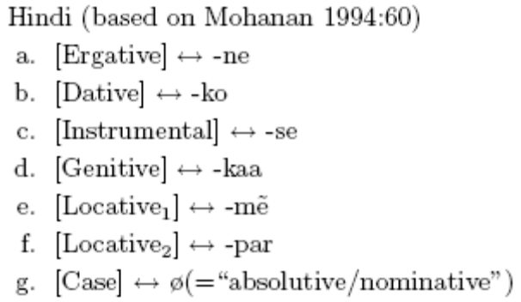

Legate 2007 claims that in fact there is no structural case in Hindi/Urdu, rather what appears to bee accusative case (-ko) is infact an inherent dative case. This is true in the verbal domain. But there does appear to be a sturcutral case, that which is assigned by posptopsitions to their complements.

However there are other elements which can be marked with this structural case, elements which are the complements of verbal elements.

Complement of the future
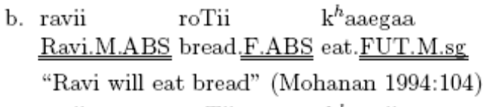

In a subjunctive
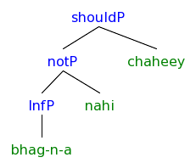
In a conditional
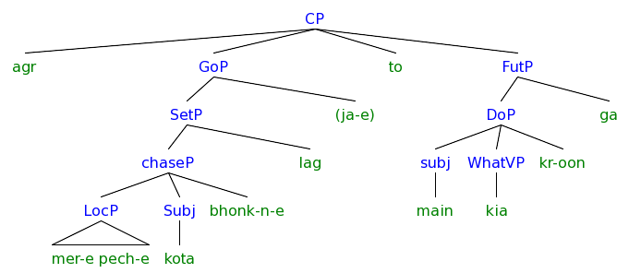
Formal request
Ajaye

Plural subject (unrelated –e ending)
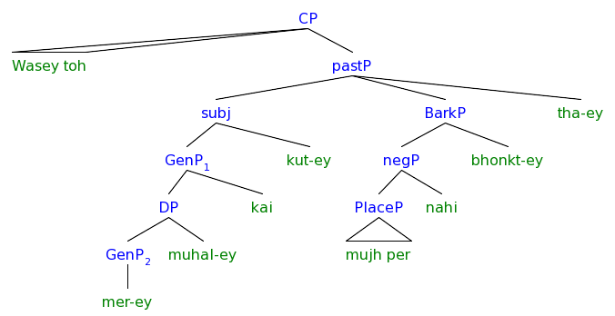

These all are united by a feeling of irealis or optative. Similar to the structural case within PPs, these are also realized on all elements inside the phrase.

In conjunctions
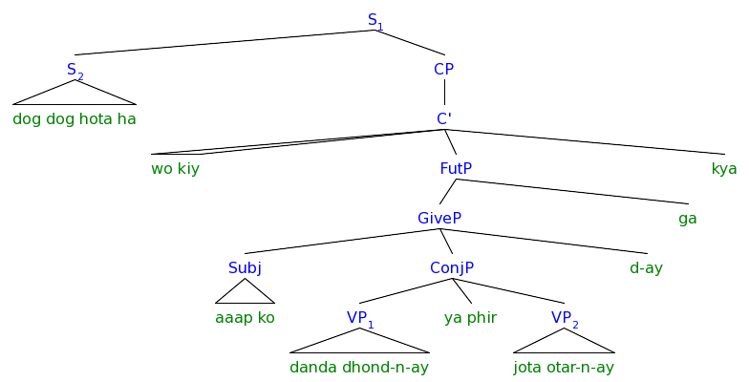

1 The internal structure of a PP

English has three locative words, `front’, `back’, and `top’ which are used instead of specialized prepositions like ‘before,’ `behind,’ `above’ etc. Svenonious refers to these two uses, as the `N use’ (the front of x) in its ‘part’ sense and the `AxPart’ use (in front of x) as the spatial sense.

- N use
There was a kangaroo in the front of the car.
- AxPart use
There was a kangaroo in front of the car.

- N use can be plural, but AxPart use cannot:
There were kangaroos in the fronts of the cars.
*There were kangaroos in fronts of the cars.

- N use can be modified by an adjective, but AxPart use cannot:
There was a kangaroo in the smashed-up front of the car.
*There was a kangaroo in smashed-up front of the car.

- AxPart can be modified by a measure, but N use cannot
*There was a kangaroo sixty feet in the front of the car.
There was a kangaroo sixty feet in front of the car.

- N use can be referred to with a proform, but AxPart use cannot.
The kangaroo was in [_{DP1} the front of the car], but the koala wasn’t in it₁.
*The kangaroo was in [_{?P1} front of the car], but the koala wasn’t in it₁.
*The kangaroo was in [_{?P1} front of a car], but the koala was in one₁ too.

- N use can strand the preposition, but AxPart use cannot.
It was the front of the car that the kangaroo was in t .
*It was front of the car that the kangaroo was in t .

Svenonious (2006:50) argues for a projection which he calls AxPart for based on Jackendoff’s (1996) and Marr’s (1982) discussion of axial structures in spatial cognition.

- Compositional Semantics of the Projections:
GenP: acts as a type shifter, lifting DPs to predicates over some of projection of N
AxPart: identifies a region based on the ground element (DP)
DP: is the ground
N use | AxPart use (Svenonious 2006:52)
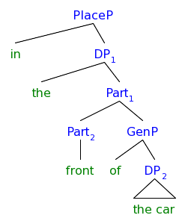 | 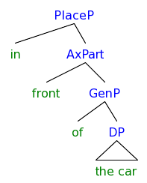

- Words which allow both AxPart and N use (Svenonious 2006:52)
in | (the) | front | of | the car
in | (the) | back | of | the car
on | (the) | top | of | the car

In the table below we see that these are the words which are ambiguous in the English prepositions and places.

- Table of (most) English Prepositions and Places
 |  | Unbounded 3D Space |  |  | Unbounded 2D Lines/Planes | Bounded 3D Object | Bounded 2D Planes
 |  |  | The Interior
Place (y) |  | The exterior, the outside | the inside, the center of the thing | The middle of the group | The field | The ground object | The side, the edge | The top, the bottom | The front, the fore, the back | The Other thing?
 |  |  |  |  | 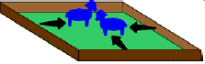 |  |  |  | 
Direction goal  (x goes P y) | goes, gives | to | to | To | to | To | To | to | to | to
Scalar |  | toward | toward | Toward | toward | toward | Toward | toward | toward | toward
 |  | into | into | Into | into | onto, upto | onto, upto | onto, upto | onto, upto | upto?
 |  |  |  | through
Direction source  (x comes P y) | comes, takes | from | from | from | from | from | From | from | from | from
 |  | out of | out of | out of | out of | Off | Off | off | off
Location  (x is P y) | be | at | at | at | at | At | At | at | at
 |  | in, outside | in, outside | in, outside | in, outside | On, by | on, by | on, by | on, by
Scalar |  |  |  |  |  | close to, next to, near, | close to, next to, near, | close to, next to, near, | close to, next to, near,
Relative |  |  |  |  |  | left of, right of, north of, south of, east of, west of | left of, right of, north of, south of, east of, west of | left of, right of, north of, south of, east of, west of | left of, right of, north of, south of, east of, west of
 |  |  | inside of, within | inside of, within |  |  |  | over, on top of, under, underneath | in front of, in back of | opposite
a- |  | around |  | among |  |  | against, along | above, | ahead of, after | across
be- |  |  |  | Between |  |  | Beside | below, beneath | before, behind
 |  |  |  |  | 2 hours |  | 10 o’clock
Time direction goal |  |  |  |  |  |  | until, to
Time direction source |  |  |  |  | since, from |  | since, from
Location |  |  |  |  | in |  | at, on
Scalar |  |  |  |  | during, within, for
Relative |  |  |  |  | before, after |  | before, after
Affective |  |  |  |  |  | For
Commitive |  |  |  |  |  | With

There appear to be three words which are ambiguous between a Noun and an AxialPart in English

front
back
top

2 Urdu also has prepositions which mean something like “in front” and take a genitive complement; does Urdu have both the AxPart use and the N use?

- Urdu Postpositions
DP Complement |  |  |  | Genitive Complement
 |  | -e |  |  |  | -e
=ko | dative | =ne | ergative | upar | `above/over/on top’ | pice | ‘behind/in back’
=tak | `to/until’ | =se | `from’ | andar | `inside’ | nice | ‘below/under’
 |  | =pe | `on’ | bic | `between/middle?’ | aage | `ahead/in front’
 |  | =me | `in’ | taraf | `towards/side’ | saamne | `in front’
 |  | =ke | genitive | paas | `near’/possession | pehle | `first?’
 |  |  |  | naazdik | `near by?’ | liye | `for’
 |  |  |  | saath | `with’
 |  |  |  | baad | `after’
 |  |  |  | (e)laavaa | `except’
 |  |  |  | tarah | `like’
 |  |  |  | binaa | `without’

Urdu has 2 postpositions which permit determiners like the noun use of “front.”
Us taraf
That side
Us tarah
That way

All postpositions allow optional DP complements.

Muriungi (2006) tests the two types of adpositions in the Bantu language Kiitharaka by the optionally of complements. These two classes of adpositions line up well with the Urdu case clitics on one hand which must have a complement, and the postpositions on the other hand which may or may not need a genitive complement.

- English
It’s in the front of the house
It’s in the front.

- Urdu
Kangaroo dube ke aage/samne/piche/upr/niche/andar baiT rehi hai.
The kangaroo is sitting in front/in front/in back/above/below/inside the box.

Kangaroo aage/samne/piche/upr/niche/andar baiT rehi hai.
The kangaroo is sitting in front/in front/in back/above/below/inside.

In this way, the Urdu postpositions are similar to their English counterparts in their noun use.

The fact that the same word can be used as a noun and as an axial part, with clearly different meanings may be an accident of the English lexicon. Other words such as in `bottom’ could have been ambiguous, but we have `below’ instead for the axial part use.

- The kangaroo is on the bottom of the box.
*The kangaroo is on bottom of the box.
The kangaroo is below the box.

I will check the axial parts in Urdu to see if any show this alternation in reference. To guide the informants I will use visuals corresponding to the two English interpretations. The fact that the two grammatical uses have the interpretations that they do is most likely an accident, so I don’t expect Urdu postpositions to behave the same.

- English:
A kangaroo is sitting in front of the box.
A kangaroo is sitting in the front of the box.

- Urdu:
kangaroo dube ke aage/saamne bait rehi hai
A Kangaroo is sitting in front of the box.
#A Kangaroo is sitting in the front of the box.

If you want to say that the kangaroo is sitting in the front of the box you need to use `in the front part/side.' The word for side `bhaag' is a formal word which I’ve never heard.

- kangaroo dube ke aage/?samne bhaag me baiT rehi hai.
The kangaroo is sitting in the front part of the box.

Try with just a postposition `in.’

- ?kangaroo dube ke aage/samne me baiT rehi hai.
The kangaroo is sitting in the front of the box.

Does pice `in back/behind’ have a nouns use?

- English
A kangaroo is sitting in back of the box.
A kangaroo is sitting in the back of the box.

- Urdu
Kangaroo dube ke piche bait rehi hai.
A Kangaroo is sitting in back of the box.
?A Kangaroo is sitting the back of the box.

- Kangaroo piche baiT rehi hai.
The kangaroo is sitting in the back (of the car).
#?The kangaroo is sitting in back (of me?).

- ?Kangaroo dube ke piche me baiT rehi hai.
A kangaroo is sitting in the back of the box.

- ?Kangaroo dube ke pichware bhaag me bait rehi hai.
A kangaroo is sitting in the back part of the house.

Does upr `over, above, on top’ have a noun use?

- English
A kangaroo is sitting on top of the box.
A kangaroo is sitting on the top of the box.

- Urdu
Kangaroo dube ke upar bait rehi hai.
A Kangaroo is sitting on top of the box.
?A Kangaroo is sitting on the top of the box.

- ?Kangaroo dube ke upr/upri me baiT rehi hai.
A kangaroo is sitting on the top of the box.

- ?Kangaroo dube ke upri bhaag me bait rehi hai.
A kangaroo is sitting on the top part of the box.

Does nice `below, under’ act like English in its ambiguities?

- English
A kangaroo is stuck under the box.
A kangaroo is stuck on the underside the box.

- Urdu
Kangaroo dube ke nice cip rehi hai.
A Kangaroo is stuck under the box.
?A Kangaroo is stuck on the underside of the box.

- ?Kangaroo dube ke nice se cip rehi hai.
A kangaroo is stuck on the underside of the box.

- ?Kangaroo dube ke nice bhaag me cip rehi hai.
A kangaroo is stuck on the underside of the box.

What about other postpositions in Urdu which seem to have an axial part use?

Does andr `inside’ have a noun use?

- English
A kangaroo is sitting in the dark inside of the box.

- Urdu
Kangaroo dube ke DARK andr bait rehi hai.
A Kangaroo is sitting in the inside of the box.

What are other ways of investigating the Axial Part use without comparing it to the idiosyncratic noun use of the English words?

Postpositions that can be added:

Derivational morphology,
In Urdu adjectives (and nouns?) can form adjectives/relative clauses? with the vaalaa/i/e suffix.

Aage-vaali gali
Saamne-vaala ghar
Pice vale dukan tha
Upr vaale raat me shor bajaate hain
Nice vale raat me shor bajaate hain

Another way of checking for an N use is to add a modifier which would go with nouns.

Check translations below, looking for nouns that correspond to the postpositions:

- Urdu AxParts, maybe look over the big table above and try to translate parts of it into urdu.
Word | Nominal Translation | Prepositional Translation
P-e |  | On
s-e |  | From
m-ẽ |  | In
Ag-e | ? | Ahead, in front
Nic-e | Underneath | Under, below
Pic-e | Behind | Behind
Saamn-aa/e | Front | in front
Tarah |  | Like
Nazdik | Vicinity | Near
Upar | Top | Above, over
Andar | Inside, interior | Inside
Taraf | Side? | Toward
Bic | Middle | Between?
Paas |  | Next to, near, possession
Pel-aa/e | First | Before
Liy-e |  | For
Baad | Later | After
Binaa | Lack? | Without
Saath-ii/Ø | Accompanyment? | With
 | Bottom
 | Edge
bahar | outside | Oudside
 | Center
 |  | Around

Appendix

Check also the DP data from

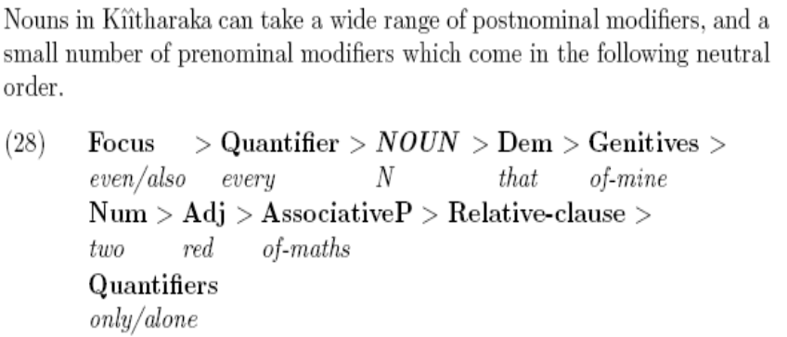

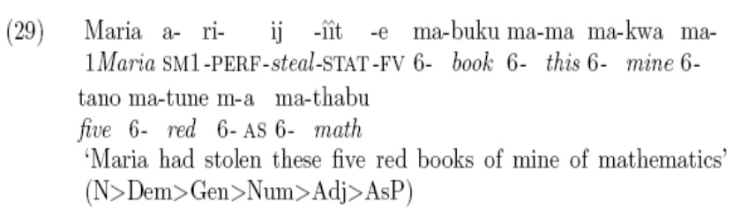

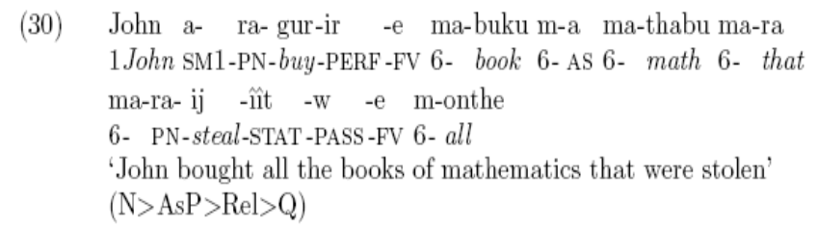

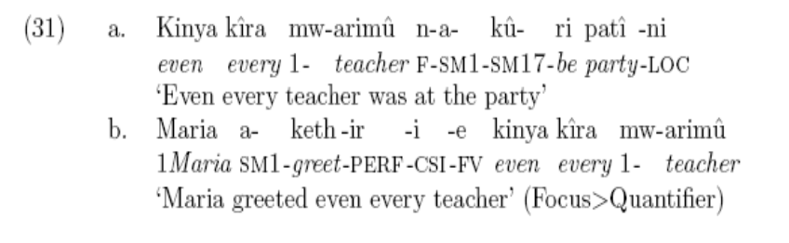

(My attempts: )
28 [mere har-ek lal-si mathmatek-i kitab hi ] le lia
29 Mary ne [mere panch lal-si mathmatik-i (ki?) kitaab hi] le lia
30 John kharide ga [us sare mathmatik-i kitaab jisne mary ne le lia]
31a Har bhi teacher party pe tha
31b Mary ne har bhi teacher ko salaam keh dia

APPENDIX preposition stacking, so far doesn’t seem to tell us much about the hierarchy…

- Table of combining and ambiguities..

Modifier | Path (moves) | Place (is) | Ground
in, on, over, off
out, up, from
 | under, underneath, above, below, around, near, beside, along, among, between |  | side, edge, front, top, bottom, center, middle, right, left, north, south, east, west | of the car
 | to, toward, through
 |  | at, beneath
in, on, over, up | to
next, close | to
out, off | of

- Preposition stacking in English
It came in from the rain.
It came in through the rain.
It came through under the bed.
It came from under the bed.
It came out up from under the bed.
?It came over down out from off the refrigerator.

 |  |  | from | under | The bed
in/out |  |  | from |  | The rain
in |  | up |  | under | The bed
out/over |  | up | from | under | The bed
over | down | out | from | over/above | The refrigerator

Prepositions which can be stacked (functional)
In, out, over, off, from, to, up, through

More lexical prepositions which can be stacked
It went along among the trees.
It went along beside the river.
It went around below under the house.
It went under around the house
*?It went between around the trees.
?It went underneath around the house.

Not on all elements, the door is too deep in this phrase: 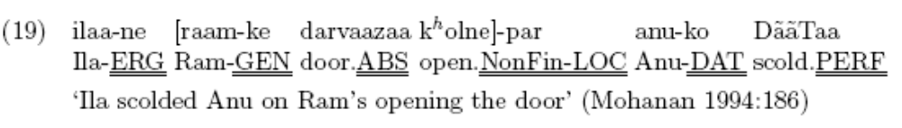
Check the paradigm of prepositions that I made, is mujh- and us- an oblique case too? Check also julies data : legate 2007:7, originally dwivedi’s data 